**Exercise 1 : Configuring a Basic Spring Application**

**Steps:**

1. **Set Up a Spring Project:**
   * Create a Maven project named LibraryManagement.
   * Add Spring Core dependencies in the pom.xml file.
2. **Configure the Application Context:**
   * Create an XML configuration file named applicationContext.xml in the src/main/resources directory.
   * Define beans for BookService and BookRepository in the XML file.
3. **Define Service and Repository Classes:**
   * Create a package com.library.service and add a class BookService.
   * Create a package com.library.repository and add a class BookRepository.
4. **Run the Application:**
   * Create a main class to load the Spring context and test the configuration.

**__________________________________________________________________________________**

* **Implementation :** 
  + 1. **Key Files :**

1. 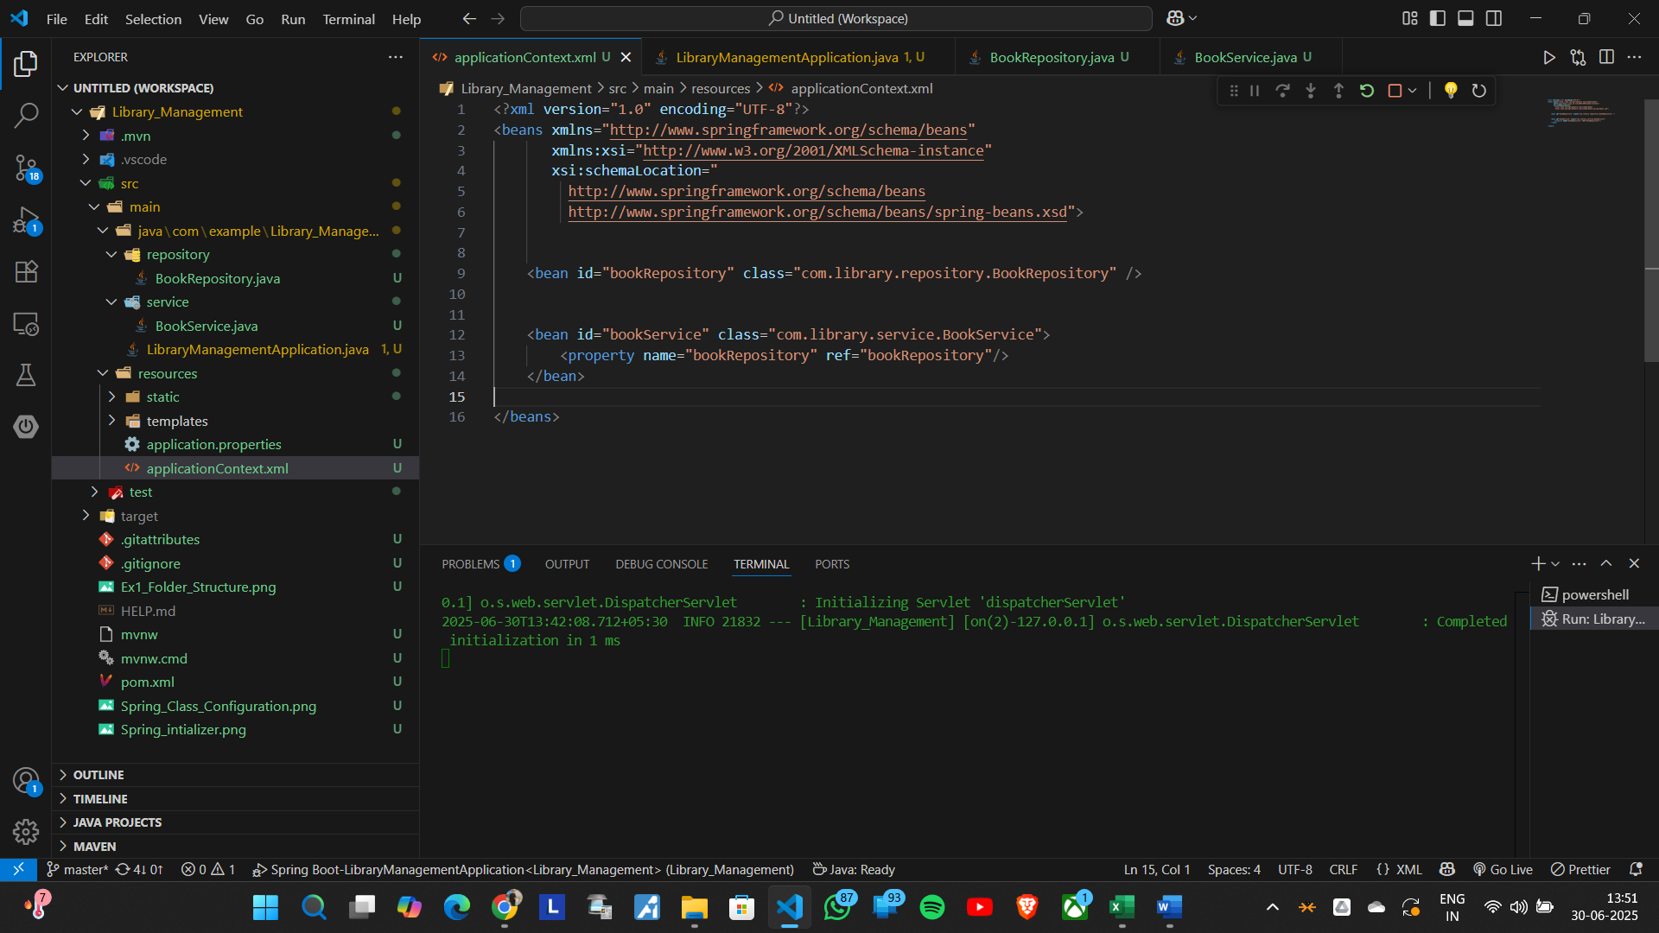**applicationContext.xml :** Defines beans for BookService and BookRepository:
2. 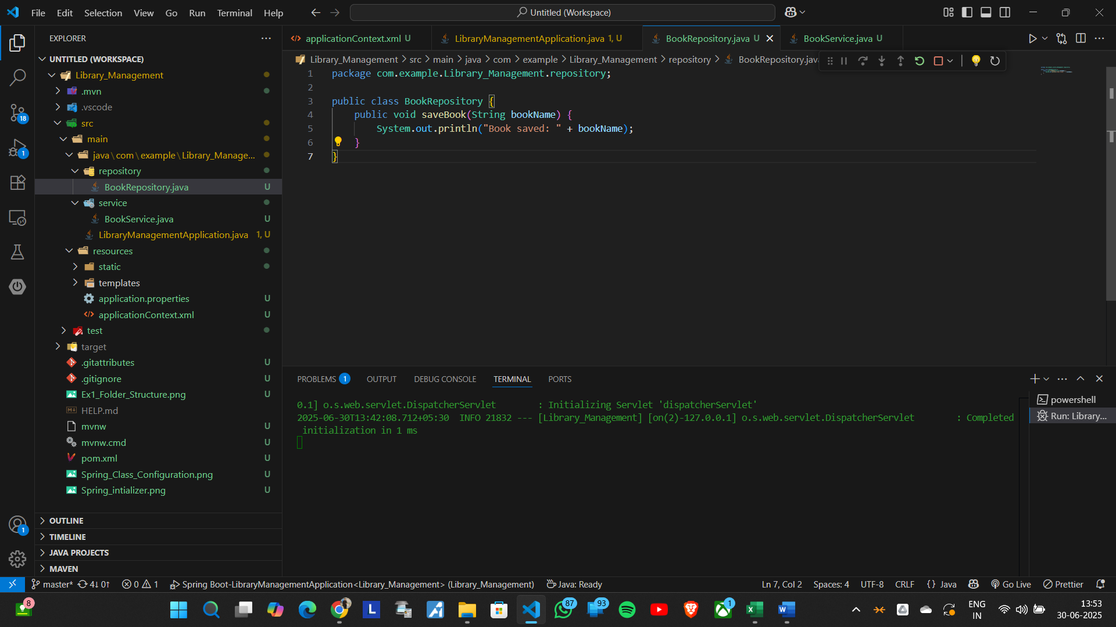**BookRepository.java :**
3. **BookService.java :** 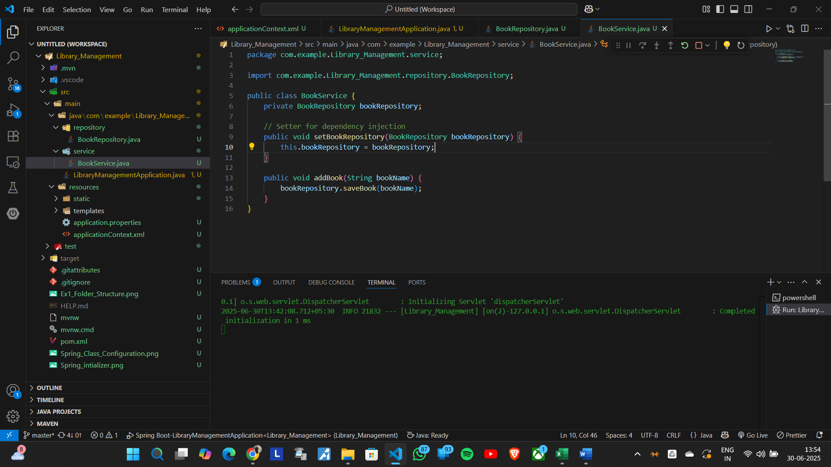
4. **LibraryManagementApplication.java**

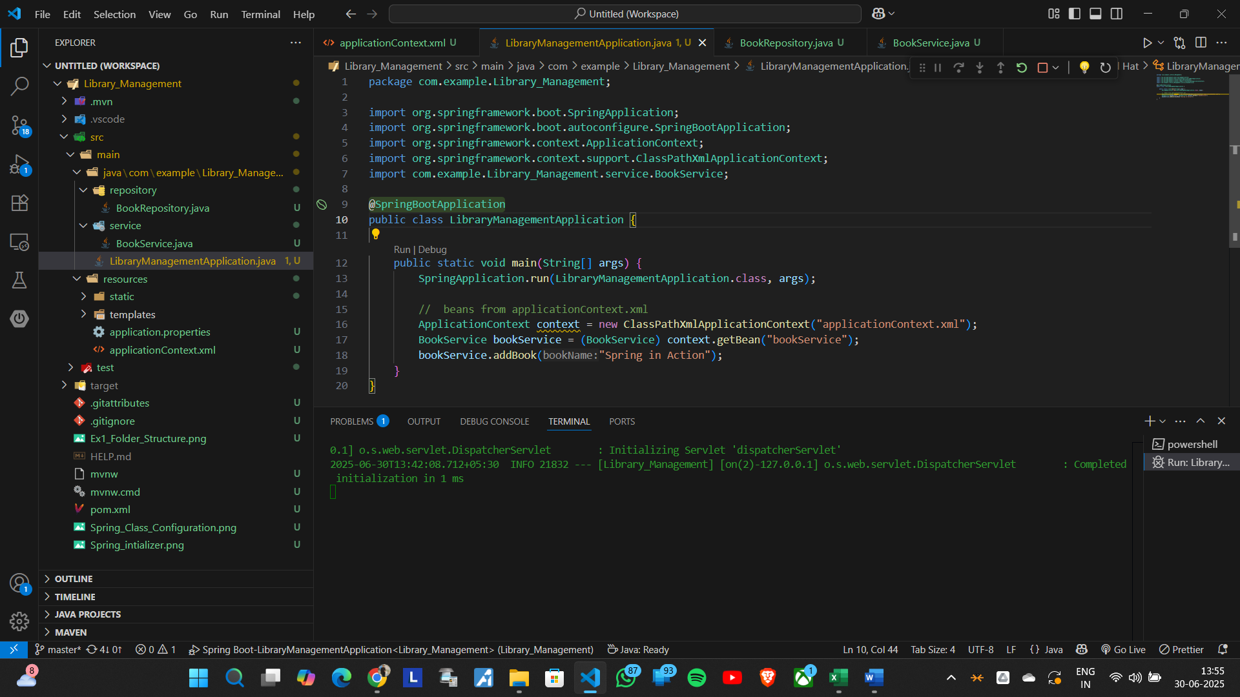

**🡪Folder Structure :**

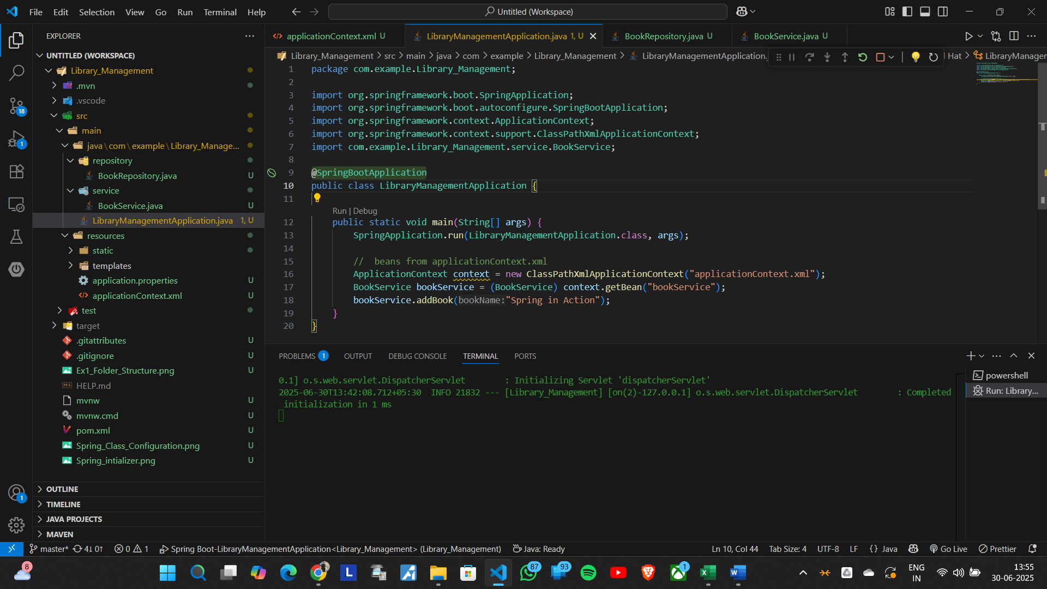

**🡪File Running Status and Screenshot**

